Chapter 5, Problem 77

Solve Prob. 5.48 using PSpice and op amp LM324.

5,48 The circuit in Fig. 5.78 is a differential amplifier driven by a bridge. Find v_{o}.

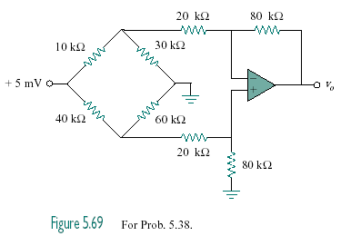
+10 mV

Figure 5.78
For Prob. 5.48 and 5.77.

